Task 1: Understanding the Uses of Spreadsheets
Creating Data from different transactions in a shop.
The Spreadsheets are used to create, record, and analyse the data in the real-world environment. In a shop, spreadsheets are used to create data from daily transactions, such as order ID, product names, quantities sold, unit sales, and total sales. This helps the business maintain accurate sales records.
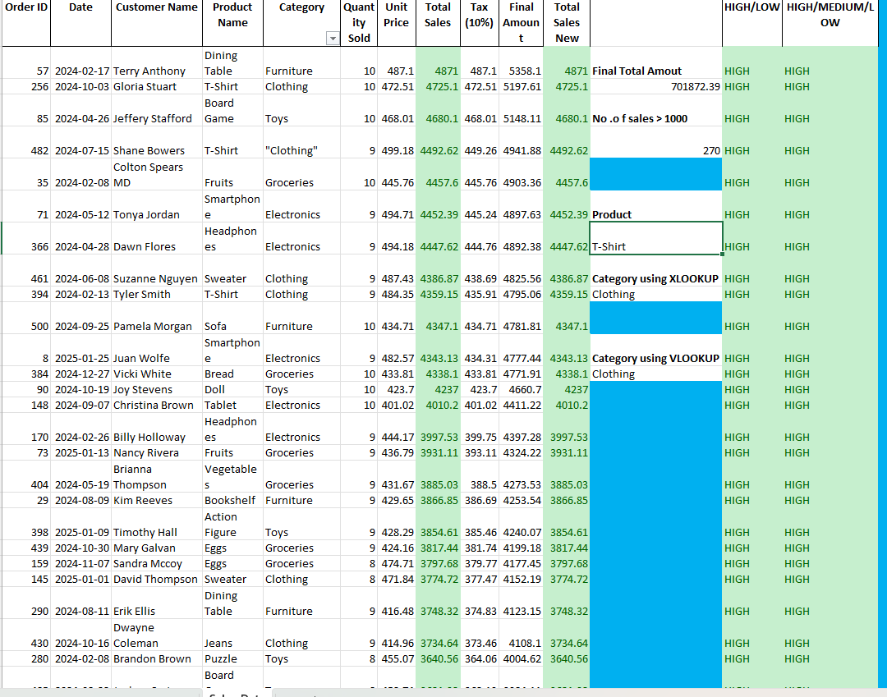

Refine the performance of sales and customers in a shop.
They are used to improve sales and customer performance by analysing which products generate the highest revenue using sorting, filtering, pivot tables, and graphs
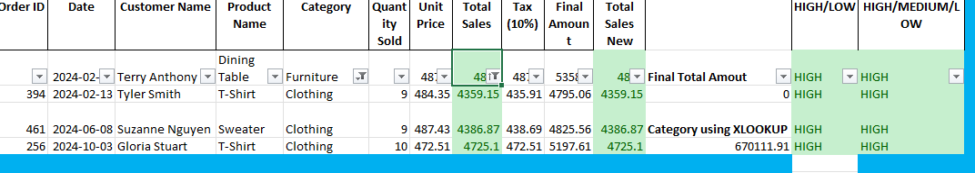
The image below shows clothing product names where total sales are above 4000, sorted in ascending order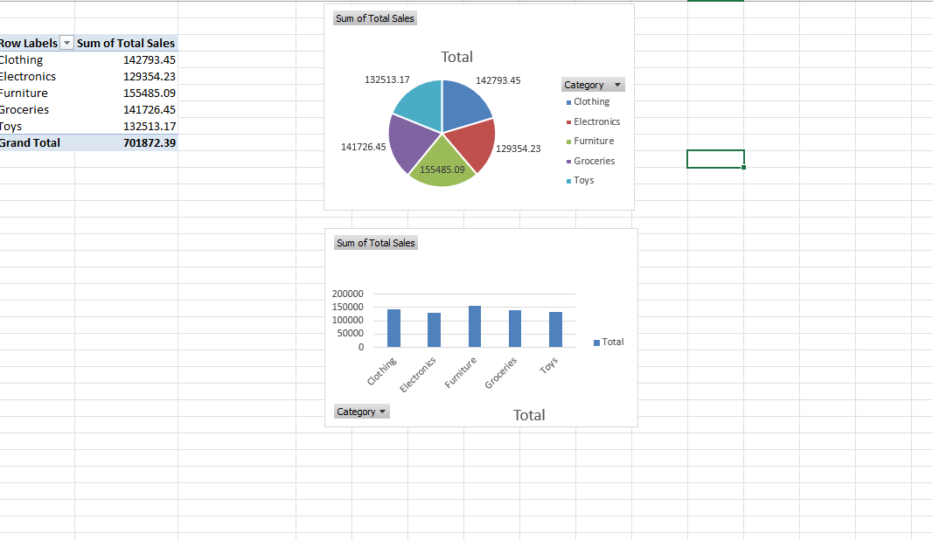

Calculating tax.
Spreadsheets help with calculating tax automatically by applying formulas such as Tax = Total Sales*10%, reducing manual errors. They also allow users to find specific order numbers and paid amounts quickly by using Find, Filter, or lookup tools.

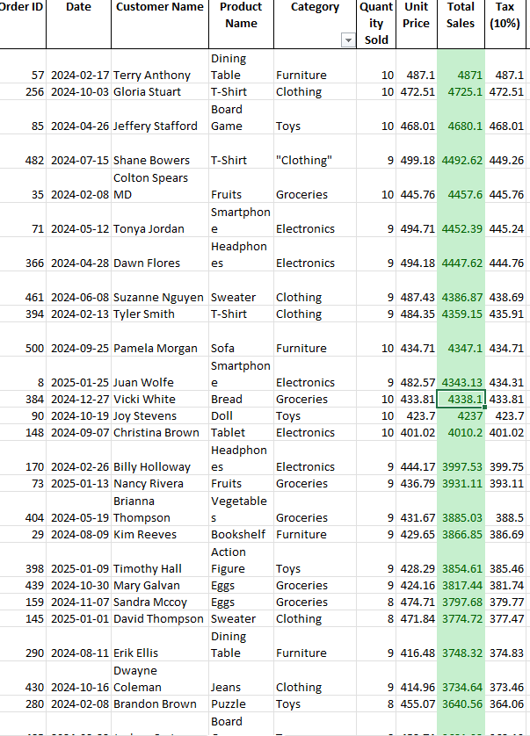
Businesses use spreadsheets to calculate total sales using functions like SUM and to produce charts that visually present trends, such as monthly revenue. Overall, spreadsheets support decision-making by allowing data to be presented clearly, analysed efficiently, and manipulated easily, enabling managers to identify problems, track performance, and plan future strategies.
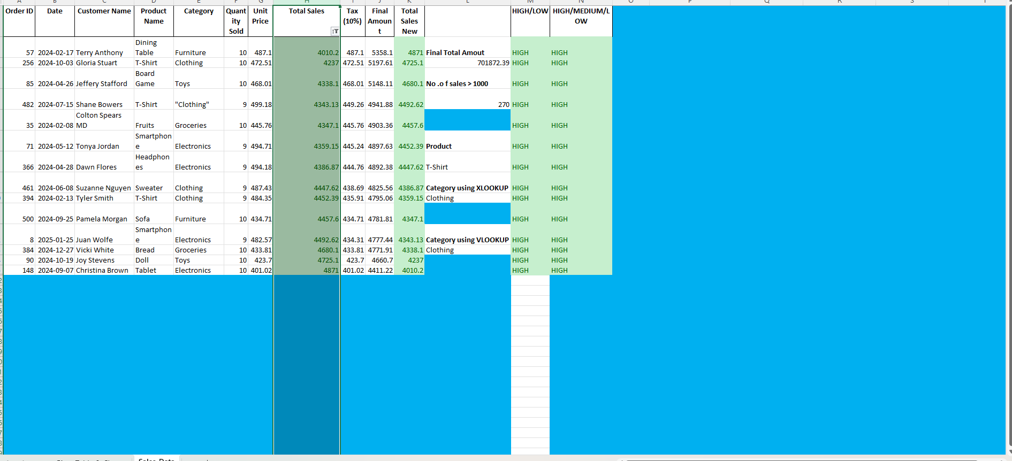

Find specific Order number and its amount paid from a range of data source.
The order number 253 and its related data are displayed
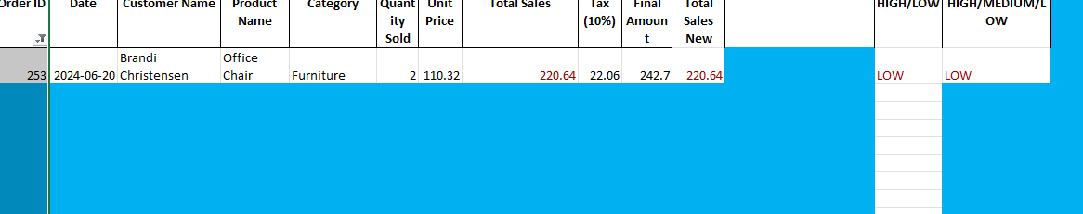
Producing charts.
Using your sales data or pivot table, you can create a bar chart or pie chart showing Total Sales by Product Category. This visually shows which products perform best.
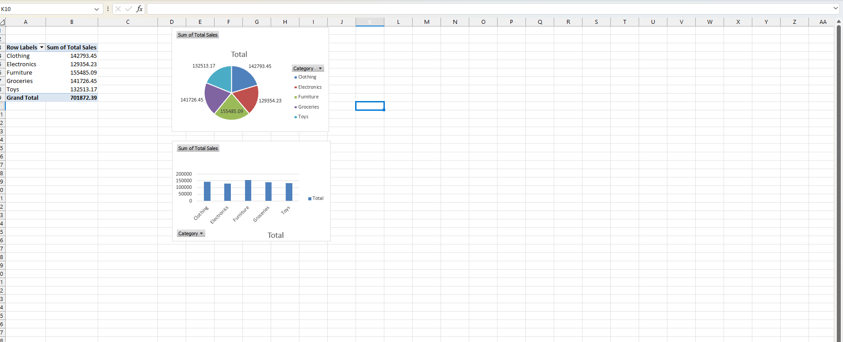

  - Calculating Total Sales.
The total sales are calculated by multiplying the quantity sold by the unit price, as shown in the image below.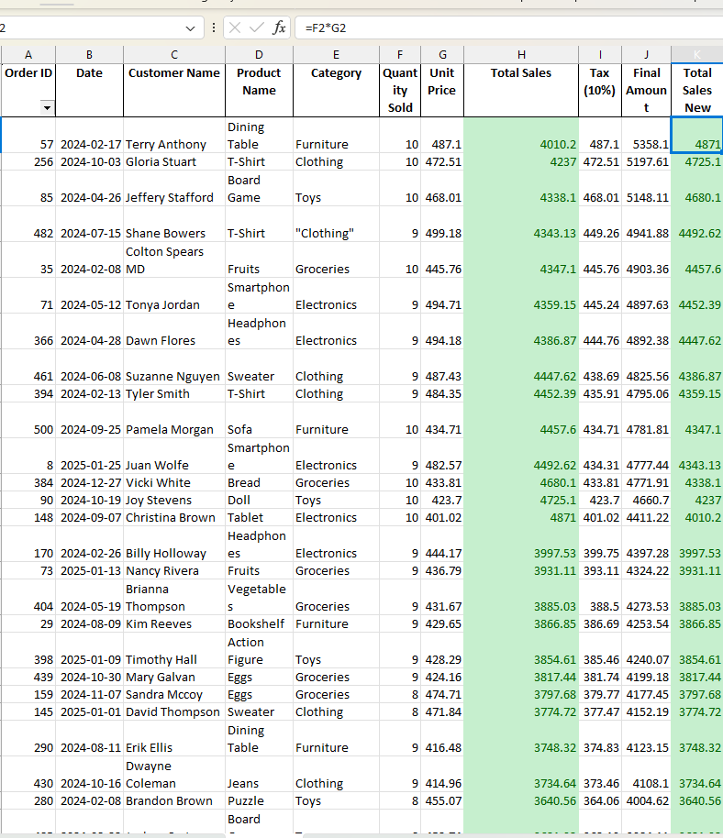

Task 2: Features of Spreadsheet Software

Cell replication and formatting (e.g., copying formulas, conditional formatting).
In your spreadsheet, formulas such as Total Sales, Tax, and Final Amount are copied down the column using the fill handle. This shows cell replication, which saves time and keeps calculations consistent. You can also apply conditional formatting to highlight high sales values (for example, values above 4000).
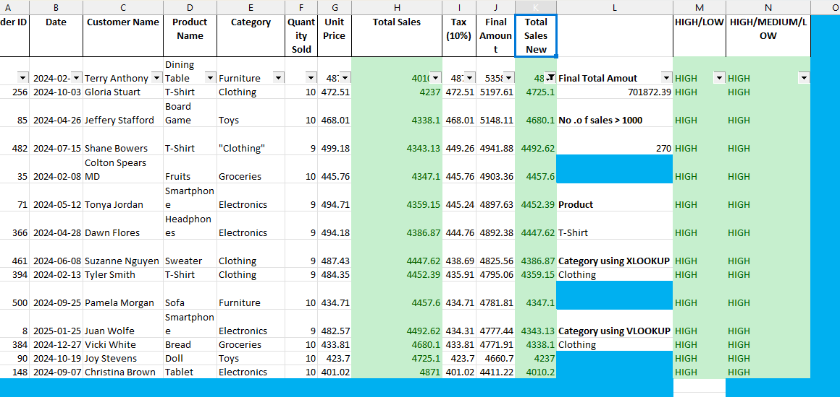

  - Functions and formulas (SUM, AVERAGE, IF)
My file uses formulas to calculate values such as Total Sales and Tax. The SUM function can be used to calculate total revenue, AVERAGE to find average sales, and IF to classify sales (e.g., “High Sale” if above 4000).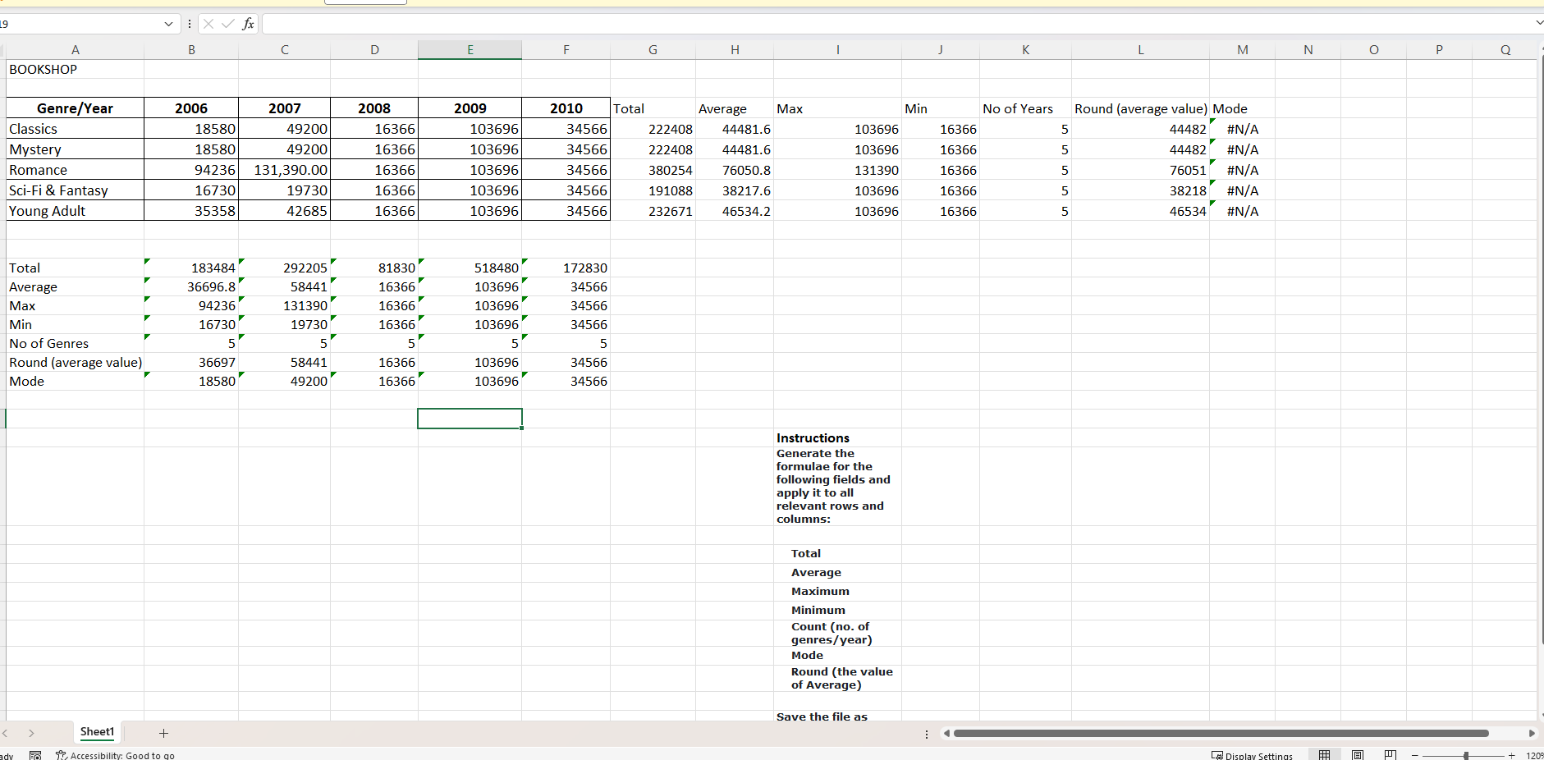
  - Page setup for printing (e.g., setting print areas, adjusting margins).
Your spreadsheet can be set for printing by selecting a print area, adjusting margins, and adding headers and footers (for example, your name and page numbers). This ensures reports print professionally.

The following PICs explains a print area, adjusting margins, and adding headers and footers

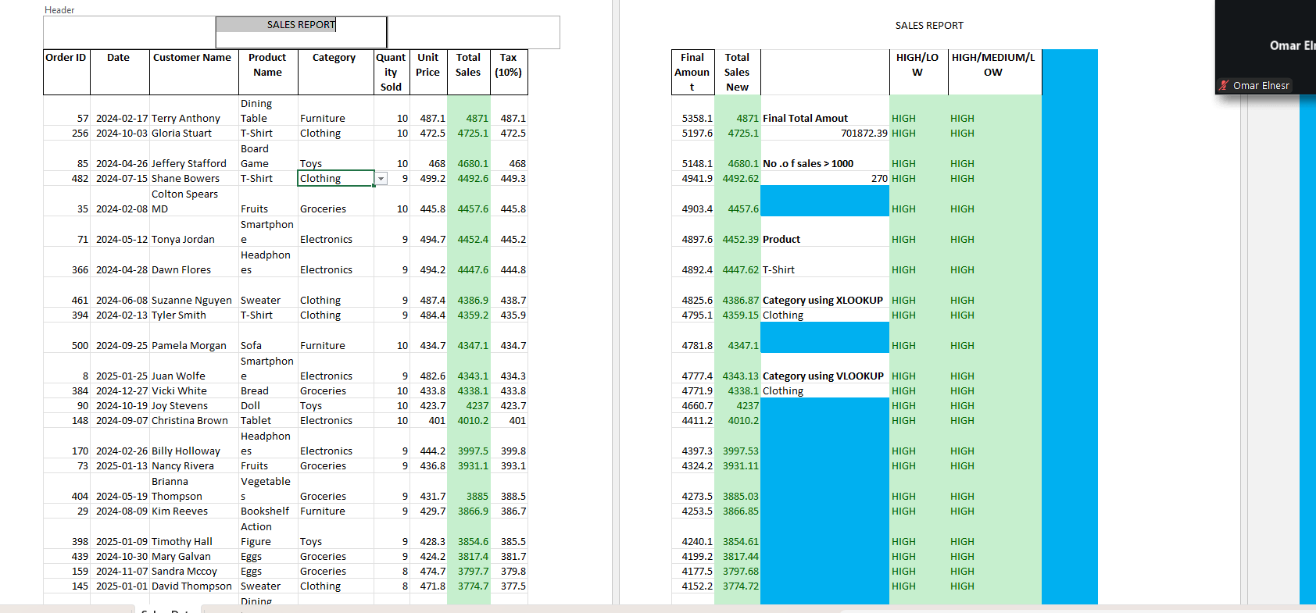
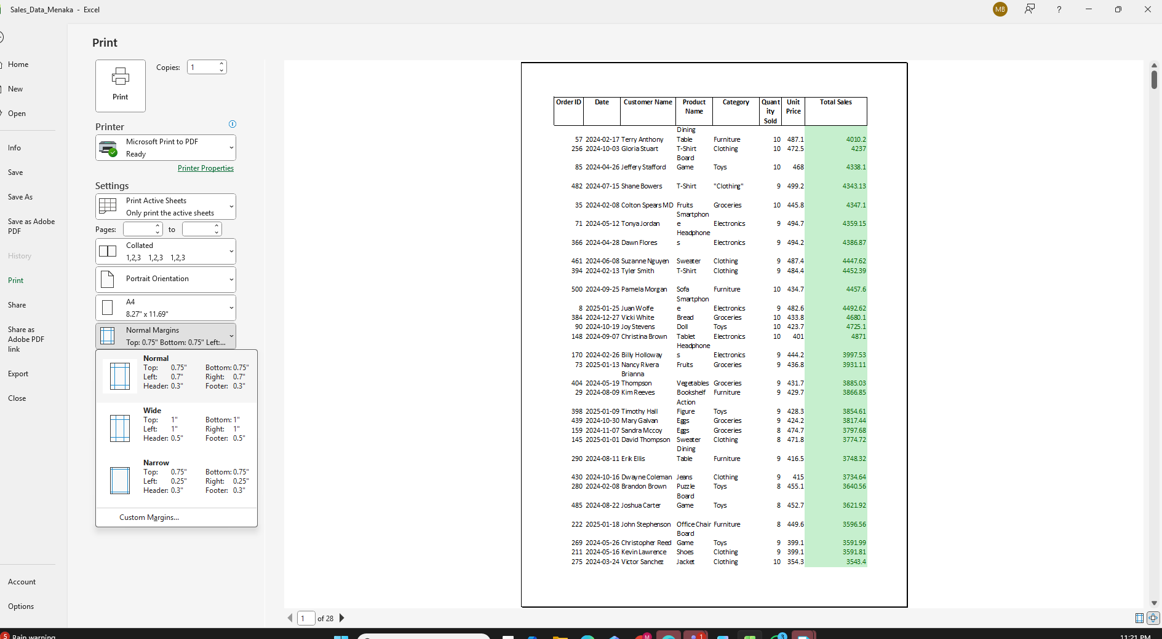

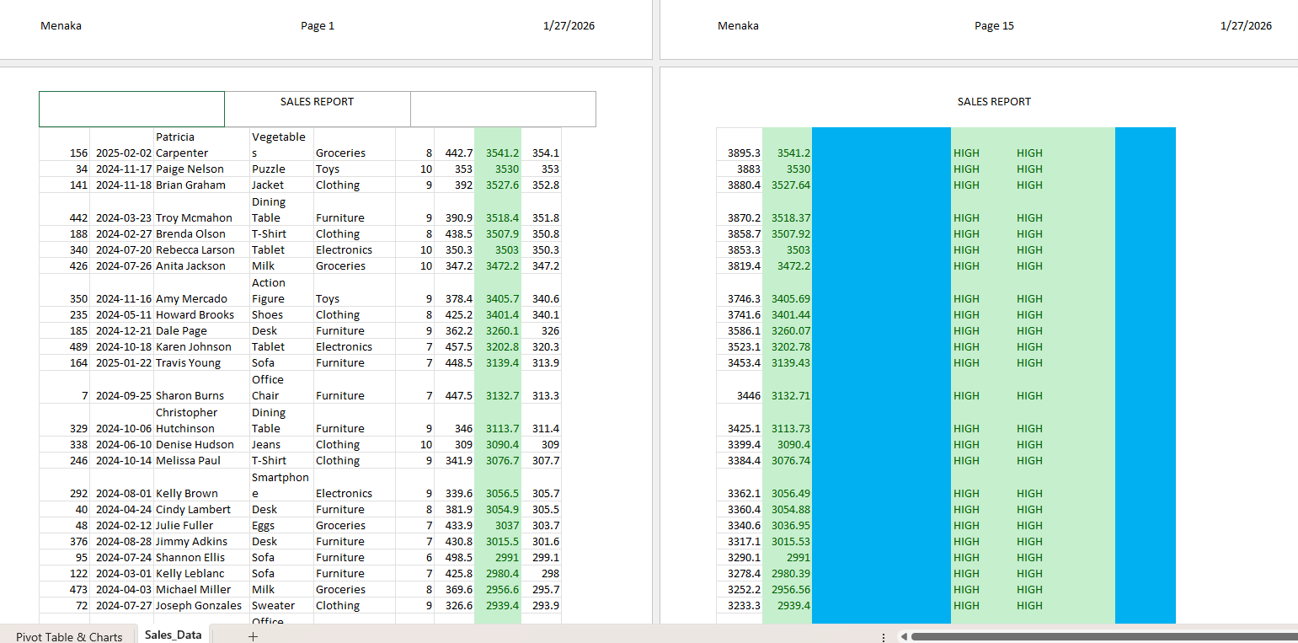

Use of graphs and charts to present data visually.
Using your sales data or pivot table, you can create a bar chart or pie chart showing Total Sales by Product Category. This visually shows which products perform best.
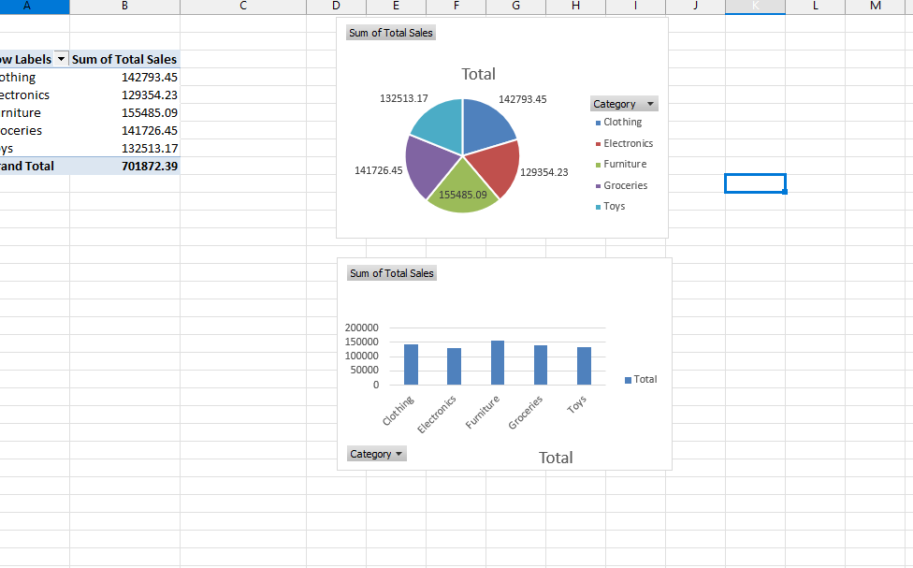
  - Automated features like macros to automate repetitive tasks.
Macros can be used to automate repetitive tasks such as formatting reports, applying filters, or refreshing pivot tables. This improves productivity and reduces manual work.

